

Across

4. Inhumane practice over which the US Civil War was fought.

6. 44th President, elected in November 2008 and left office in January 2017.

10. Long-running US cartoon comedy programme.

12. Spanish-speaking southern neighbor of the USA.

Crossword



*News*

**Just**

Down

1. US State home to Disney World and Kennedy Space Centre.

2. Scandal and cover-up which lead to President Nixon’s resignation.

3. Shared name of US automotive brand and 38th President.

4. 2nd most spoken language in the USA.

5. Fried dough snacks favoured by cops and H.Simpson

7. Large southern state known as the ‘Lone Star’.

8. Hearty, spicy soup popular in the Deep South, particularly Louisiana.

9. Fast-food popular at sporting events, often served with mustard and ketchup.

11. American name for Association Football.

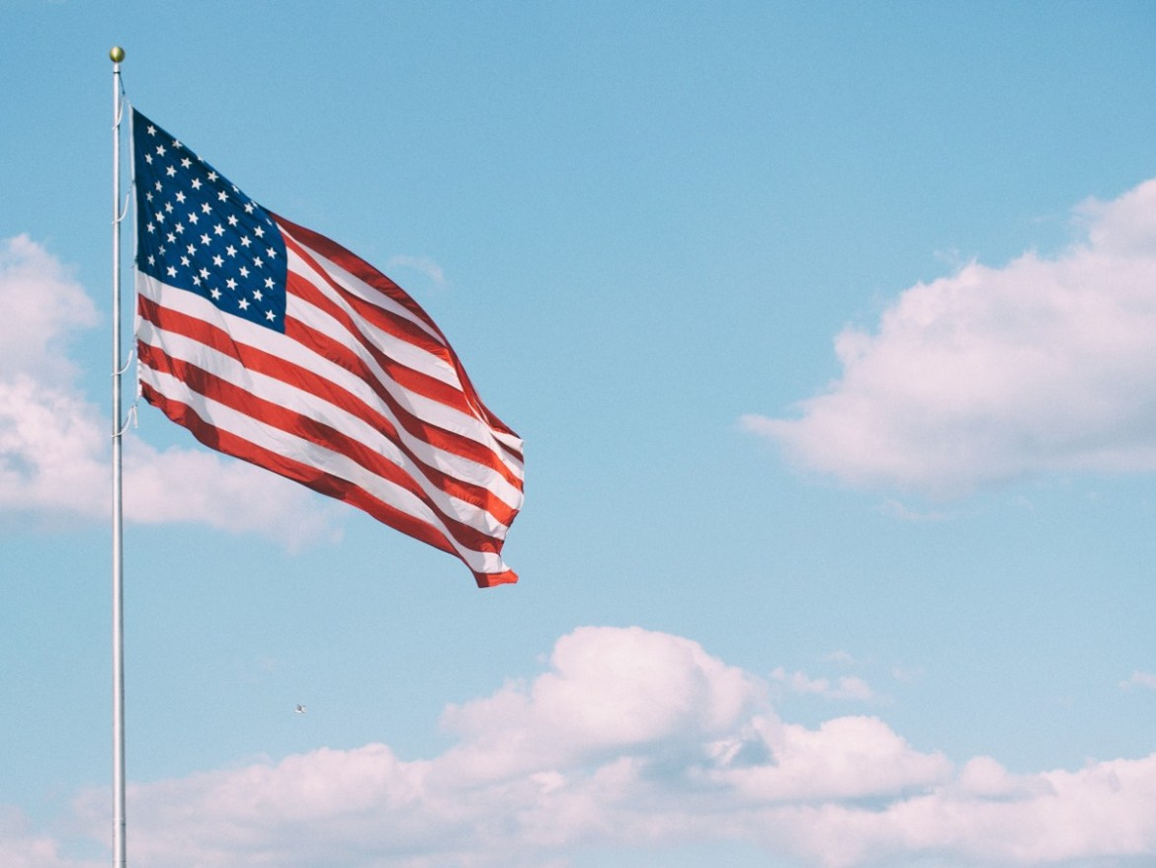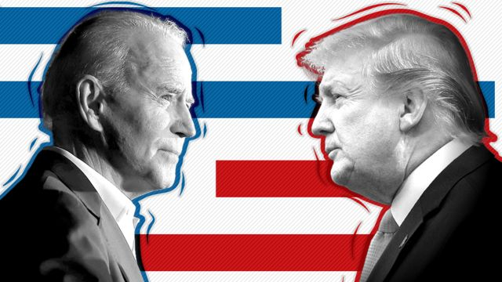

USA

Last Week’s Quiz Answers:

1. Catherine
2. Hedgehogs
3. The Gunpowder Plot
4. China
5. 1605
6. James I
7. Catholic
8. Pyrotechnics
9. Billy Joel
10. Parkin Cake
11. Gunpowder, treason and plot!
12. Money (Pennies)
13. New Year’s Eve, Diwali and Chinese New Year.
14. How many states currently make up the USA?
15. Which historic highway runs from Missouri through to Arizona?
16. What fruit based desert completes the saying “As American as...”?
17. The USA is sometimes known as “the land of the free and the home of the...” what?
18. Which US President had a previous career as an actor in Hollywood B-Movies?
19. Name either of the 2 US states that do not share a land border with the mainland continental USA?
20. *Friends*, *Seinfeld* and *How I Met Your Mother* are all sitcoms set in which US city?
21. Which country is bigger by total area - the USA or Canada?
22. Which former country was the USA’s main adversary in the ‘Cold War’ from 1947 to 1991?
23. How many US Presidents have been assassinated whilst in office?
24. Malcolm X and Martin Luther King Jnr were prominent Black leaders in which US political movement?
25. Which sport is sometimes known as ‘America’s National Game’?
26. Hollywood studios can be found in which Californian city?

* New York used to known as New Amsterdam - it was originally a Dutch settlement before being captured and taken over by the British in the 17th century, and it was renamed after the Duke of York who helped capture it, not the English city.
* And Alaska used to be a part of Russia. The US purchased the land from the Russian Emperor Alexander II in 1867 for $7.2 million (about $132 million in today’s money), equivalent to 2 cents per acre of land.
* Joe Biden is now the 14th person to be elected President of the United States after previously serving as Vice-President.
* Philadelphia served as the temporary capital of the United States between 1790 and 1800 whilst Washington D.C was being built.
* When alcohol was banned in the USA during the Prohibition Era, the US government decided to poison industrial alcohol in order to prevent it being stolen and made drinkable. By the time prohibition ended in 1933, it is estimated that this government poisoning programme had killed over 10,000 Americans.
* The state of Kansas could singlehandedly feed the world for 2 whole weeks. That’s because the state produces enough wheat each year to make 36 billion loaves of bread - which works out at between 4.5 and 5 loaves per person for the fortnight, I guess you could make them last longer if you had a freezer though!
* Presumably using some of that wheat from Kansas, America produces and consumes about 100 acres of pizza each day - equivalent to about 3 billion whole pizzas sold each year in the country.

Quiz Time!

Poem Corner

Joke Corner