Housing Conditions in England – Justlife’s response

Who we are

Justlife is a charity supporting and advocating for people living in temporary accommodation (TA). We have two support centres, in Brighton and Manchester, where we help homeless households to access housing, health, and benefits support. Nationally, our Campaigns and Social Change team work to influence policy around housing and homelessness, in part through our position as co-secretariat to the APPG for Households in Temporary Accommodation, alongside the Shared Health Foundation.

Our expertise/A summary of our response

Our Campaigns and Social Change team have spent years doing research into the reality of life in temporary accommodation. From our first report Not Home, released in 2014, to this year’s Better Vision for Temporary Accommodation, we’ve consistently heard from those with lived experience of homelessness, as well as other experts, that conditions in TA are appalling. We’ve found many of the same issues identified in the Committee’s own report into child homelessness, such as damp and mould, overcrowding, infestations, a lack of basic amenities, and more.

We’ve also been consistent in our calls for policy change. We’re encouraged by the prospect of applying a strengthened Decent Homes Standard to temporary accommodation and believe this should cover all TA. We know from our work, however, that TA isn’t treated in the same way as other forms of housing.

The little regulation that does exist, such as the obligation to avoid a category 1 hazard under the HHSRS, is not applied in the same way to TA as it is to other forms of housing, with these hazards being commonplace. Even rules around TA being ‘suitable’ (Part VII of the Housing Act 1996) are ill-defined and not sufficiently enforced by the Local Government and Social Care Ombudsman.

Therefore, on top of applying the Decent Homes Standard, we’d like to see new legislation passed which specifically and explicitly creates standards for temporary accommodation. As with other statutory services, we’d like to see this new legislation create a regulatory body specifically for TA, to enforce these new standards.

The following response focusses on the final 3 questions in the call and provides our evidence on conditions in temporary and exempt accommodation as well as detailing the changes we need to make. Our evidence draws from a number of recent research projects and calls for feedback.

Temporary Accommodation - Question 1
How prevalent are the “appalling conditions” the Committee found in some instances of temporary accommodation in its recent inquiry, and how can the Government best address this?

The Committee’s recent inquiry found the following issues of poor-quality accommodation:
- Serious hazards – such as damp & mould, excessive cold, or pest infestation.
- Overcrowding – including whole families living, studying, and sleeping in one room.
- Poor maintenance – including faulty plumbing, broken furniture, and out of order bathroom facilities.
- Lack of adequate facilities – including missing or shared kitchen, laundry, and personal hygiene facilities, as well as a lack of Wifi and study equipment for schoolchildren.

These findings were not a surprise to us. Through our research, particularly that conducted alongside those with lived experience, we have heard many of the same stories.

APPG for Households in Temporary Accommodation – Call for evidence (2023)

In 2022, the APPGHTA launched a call to gather written and photographic evidence of conditions in temporary accommodation from people who have lived, or support someone who is living, in TA. 81 individuals from across England took part, sharing their stories and experiences with us. In early 2023, we published our findings, including the following issues with conditions in TA:

- Poor maintenance – more than half (41) of the respondents reported issues of poor maintenance, including uncleanliness (30), mould and/or damp (18), the building being in a state of dangerous disrepair (16), infestations ranging from mice, cockroaches to slugs and snails (11), leaks (7) and fire safety issues (5).
- Lack of basic household goods/amenities – 18 respondents mentioned a lack of basic goods/amenities, including no or limited cooking facilities, lack of working/appropriate household goods, no/limited plumbing, and no/limited electricity and/or heating. Several people talked about arriving at their property to find stained, filthy mattresses, or a complete lack of basic goods such as duvets or curtains.
- Accessibility issues - 31 people referenced having one or more disabilities and their TA experience being unsuitable because of it. People talked about experiencing serious accessibility issues in their property such as not being able to use showers, bunk beds or get up and down stairs. One respondent, who was placed in a hotel while awaiting more long-term accommodation, was unable to have their mobility device stored in their room with them, effectively meaning they were unable to move from their room.
- Sense of unsafety - 14 people used the words “I felt unsafe” while describing their TA experience, 7 people stated they felt traumatised by their time in TA, and 4 people explicitly said they would prefer to sleep rough to staying in their TA due to feeling unsafe there. The experience of “Unsafety” in the submissions we received were for 3 reasons: other residents, building security, and adverse environments.

Temporary Accommodation Action Groups (TAAGs) - feedback (2025)

In preparation for this response to your inquiry, we also gathered some feedback from members of our Temporary Accommodation Action Groups (TAAGs). TAAGs are multi-agency groups that include stakeholders around TA in a local authority area, including LA Housing, private TA providers, charities and people with lived experience. The following is a breakdown of the responses we received from each TAAG by location.

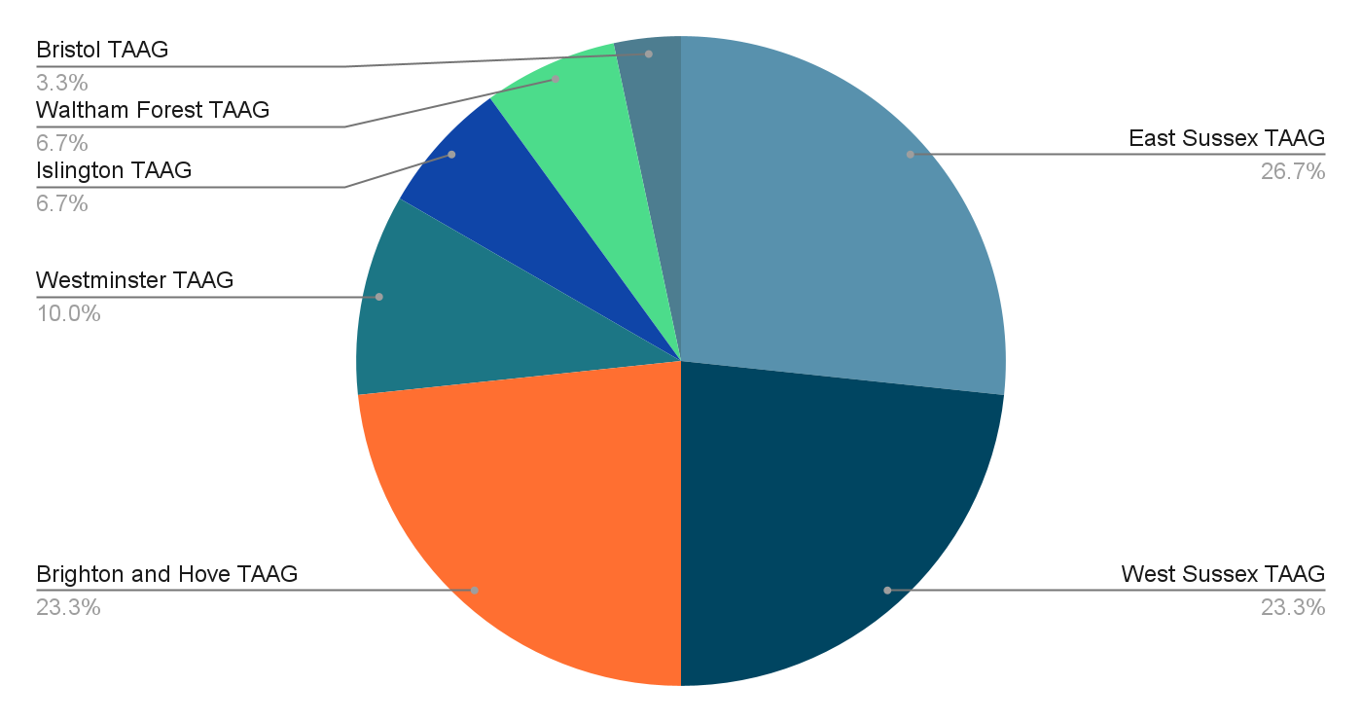

When asked how prevalent appalling conditions are, they said the following:

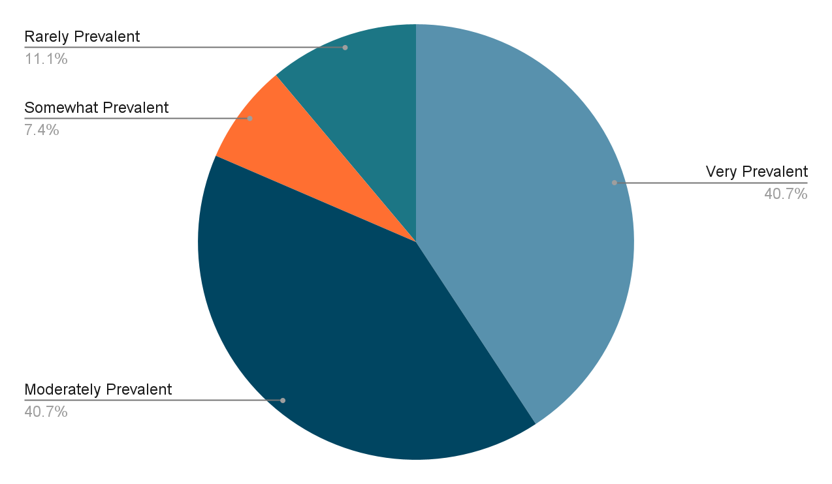

When asked how the government should address these conditions, some respondents argued there should be a focus on prevention, and investing to save through benefit reform. One member said: “The government needs to look at the root causes of homelessness…when a family in receipt of benefits is evicted by their landlord, it is almost impossible for them to find affordable accommodation themselves - due to high rents, unrealistic LHA rates and the benefit cap.”

Others wanted to see greater funding for local authorities to buy up property for use as TA. The feeling was that private providers are less likely or able to provide quality accommodation at an affordable rate. One respondent said: “Local Authority owned accommodation is much better in terms of conditions.”

The overwhelming theme from responses was the need for better enforcement of existing and any new regulations. Many respondents specifically called for a regulator to oversee conditions in temporary accommodation. One respondent said we need to “introduce new legislation for TA including measurable standards with KPI's…Introduce regulators either as a central body similar to CQC or as part of LA housing/planning teams”

These recommendations chime with what we’ve found in other research. The appalling conditions in TA are out of control, and this can only be solved by explicitly naming the problem and its solution in legislation. It’s also key that we have a regulator to enforce standards. We recommend this regulator be independent, to avoid a situation where local authorities are regulating either themselves or the private providers they’re relying on.

Frontline feedback (2024)

In 2024 we carried out interviews with 16 of Justlife’s frontline workers. Their work requires them to spend much of their time visiting clients in their Temporary and Emergency Accommodation in Brighton and Manchester. We asked them how they find the conditions, and all 16 told us of their concerns for the majority of this kind of accommodation. This aligns closely with the findings from our Call for Evidence and the Better Vision Report.

Specifically around:
- Serious hazards: “We've had people who don't even have respiratory problems getting diagnosed with them, and you can hear them coughing and they just sound awful. And it's because of where they're living and nothing seems to ever get done about that. It's quite frustrating to watch people's health decline just 'cause of where they're living”
“We recently had a lot of people that were living in places with really bad pest infestations and hadn't even told us about it. I only knew about it when one of my guys lifted his jeans up and his legs were covered in red dots”
- Overcrowding: “I can't imagine what it must be like for somebody with autism to be in somewhere that's like emergency accommodation because it's loud, it's chaotic, it's, I just can't even picture how difficult it must be for them to cope.”
- Poor maintenance: “You know, you've got somebody in a room with water pouring through the ceiling and a wet mattress and nothing to eat”
“Like something out of a Dickensian novel”
- Lacking in basic facilities: “I had a woman phone me the other day who’d been put in temporary accommodation by the council and had no electricity. And she’s got a young child and they were just like, we can’t get in touch with the landlord. And she couldn’t cook. She couldn’t clean her child. She was so distressed.”

Peer Research findings (2025)
A group of four people with lived experience of staying in TA were supported by Justlife to carry out their own research. They carried out a focus group with 8 frontline workers supporting people in TA.

The findings from the focus group supports other evidence presented here.

Specifically:
- Serious hazards:
“No locks on door”
“I have seen diagrams of lung issues from mould! Respiratory disease/lung capacity because of damp… COPD”
- Poor maintenance:
"High reliance on unsuitable accommodations due to a shortage of TA options"
"People shouldn’t be housed together in poor conditions"
- Lacking in basic facilities:
“Poor nutrition if you only have a microwave. Especially as a diabetic”
“A place to get washed; you can’t.”

A Better Vision for Temporary Accommodation (2025)

A year after publishing the Call for evidence (2023), Justlife decided to work on a complimentary piece of work, which focussed on the solutions to the housing crisis, including how we can improve conditions in temporary accommodation. Our research included conversations with 131 people, including both those who have spent time in TA, as well as those who work in and around the housing and homelessness sector. Our findings were published in May this year and raised the following serious issues of poor conditions in temporary accommodation.

- Uncleanliness - The majority of respondents with lived experience raised a lack of cleanliness as an issue they had faced. We heard about faeces left on the floor and walls, rat and cockroach infestations, and kitchen surfaces left to develop mould.
- Damp & mould – Many participants highlighted damp & mould as a problem in TA. One participant shared the following story: “The whole pillow part of (my) mattress is covered with mould, so I’m not sleeping on the bed. Me and my son, we are sleeping on the floor…I thought that we are getting sick, maybe of the mould from the washroom and kitchen, but actually it’s in the blanket and it’s in the mattress as well. So, it’s everywhere.”
- Poor security - Some participants expressed a fear for their own safety while in temporary accommodation. Some described staying in HMO properties without functioning locks on the windows or doors. Many highlighted risks associated with placing women and children in the same spaces as single male adults, which is common.
- Lack of space/overcrowding – Many participants complained that there was insufficient space in TA, particularly for families. One participant said: “I have four children and I’m together in one room with the four…. My kids don’t have space to play… it’s affecting my mental health as well as that of the children.”
- Lack of facilities/amenities – participants raised a lack of facilities and amenities like Wi-Fi, laundry, flooring, and curtains. Most important to respondents was the consistent lack of cooking facilities, particularly in hotels, hostels, and B&Bs.

The report proposed solutions, including the need to apply the Decent Homes Standard (DHS) to TA. The DHS would be a good starting point to begin to raise TA standards; it requires that a property must have reasonably modern facilities and services, and that it be in a reasonable state of repair.

With the help of Paula Barker MP, we submitted an amendment to the Renters Rights Bill to automatically apply the standard to all temporary accommodation. The government rejected the amendment, citing the fact that many examples of TA, e.g. hotels and hostels, could not reasonably comply with certain requirements, including the need to have a self-contained bathroom and kitchen. However, our Better Vision report found that, according to MHCLG guidance, a property would not fail compliance “where it is impossible to make the required improvements to components for physical or planning reasons.”

This raises the alternative concern that the DHS cannot, in its current form, raise the condition of TA to the standard that residents deserve. Therefore, we recommend it be strengthened. This will of course need to go alongside an increase in the supply of both temporary and permanent housing, which we’re glad to see movement on from the government in recent months.

Even in a strengthened form, however, we still had concerns around the way the standard would be applied to TA. For example, part of the DHS already applies to temporary accommodation: the need to meet ‘the current statutory minimum standard for housing’, which is avoiding ‘serious hazards’ under the Housing Health and Safety Rating System (HHSRS). Examples given of potential category 1 hazards include damp and mould, a lack of cleanliness, a lack of security, and a lack of sufficient space. Within the HHSRS, category one hazards are described as ‘the most dangerous and life threatening’.

As we know many of these serious hazards are commonplace in TA, we doubt the ability of existing legislation to effectively regulate temporary accommodation. TA is always treated differently, for many reasons: residents are seen as deserving of their situation; people see poor conditions as acceptable as its ‘only temporary’; there are concerns about landlords leaving the market. The result is rules not being applied when it's TA.

To address this and to truly improve conditions, we recommended in our report that new legislation creates standards specifically for TA, with an independent regulator overseeing their enforcement. We have regulators for all other statutory services, and there is an equal or even greater need in the temporary accommodation sector.

Temporary Accommodation - Question 2
Has there been any progress in tackling the “shocking conditions” in exempt accommodation, identified by the predecessor to this Committee in 2022?

We know from our experience supporting residents, and from our research, that many of the issues of housing conditions that exist in temporary accommodation generally, also exist in exempt TA. We’re similarly seeing cases of damp & mould, overcrowding, poor facilities/amenities, unsecure housing, and more. That was the case at the time of the DLUHC report, and it remains the case today.

Temporary Accommodation Action Groups (TAAGs) - feedback (2025)

80% of our TAAG respondents said there had been minimal/no progress, or a regression in conditions in exempt accommodation since the publishing of the report. 20% believed there had been some progress. None of our respondents identified moderate or significant progress.

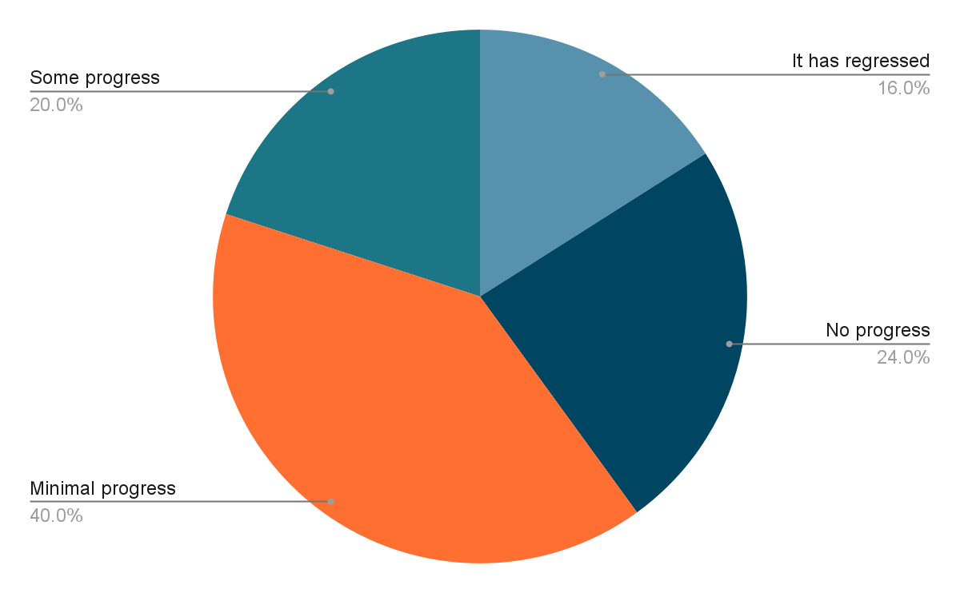

Of those respondents who saw progress since 2022, 2 identified the housing provider as the cause. One respondent said they “have seen more local authority managed TA rather than private landlords.” This is also something we’ve witnessed through our work at Justlife, as some local authorities are buying up property on the open market (often ex-Right to Buy housing), for use as TA. This was a recommendation in our Better Vision report, as we see local authorities as better placed to provide both quality support and decent accommodation to residents.

However, the majority of respondents were less positive about the state of exempt accommodation. As was identified in the DLUHC report, respondents were seeing the same issues of ‘astonishing’ levels of crime. This was seen as adding to a general feeling and reality of unsafety.

One respondent working in exempt TA said their “service users are reporting worse conditions/more instances of inaction or ineffective action”. Another respondent listed these conditions as including “child deaths in TA, no cooking facilities, no locks on doors, blood on mattresses when people move in, no locks on windows.”

Many saw the issue as one of underfunding or a lack of staff: “If you do nothing, nothing will change. Local authorities have the tools to tackle poor accommodation, but they lack the staff.”

One of our TAAG respondents argued that “the Supported Housing Act has enabled some progress to be made”, although it was unclear in which way they believe this has helped improve conditions.

Supported Accommodation Act 2023

As we understand it, the Supported Accommodation Act 2023 granted the Secretary of State powers to create ‘National Supported Housing Standards.’ These were consulted on and include the following principles:

- Person-centred
- Respectful
- Safe and responsive
- Effective
- Well led

These principles, however, only apply to the support offered to residents in exempt accommodation. They are a positive and much needed addition, but they will not provide for better enforcement of housing conditions/quality.

In fact, the government made clear in its consultation that the Act “is not creating new accommodation quality standards for supported housing”. Instead, “Supported housing schemes applying for a licence should meet the existing accommodation requirements and standards relevant to their housing tenure.” However, as we’ve outlined, there is currently little in the way of existing requirements and standards for TA, and these are not enforced.

Local authorities will be capable of requiring that providers of exempt accommodation carry a license. They will be able to revoke this license for a number of reasons, including if they see the provider as not passing the ‘fit and proper person’ test, or as not meeting the National Supported Housing Standards/principles.

However, our concern would be that, due to the demand for temporary accommodation among local authorities, as well as how TA is always treated differently to other forms of housing, that councils will be disincentivised from revoking licenses, even where malpractice exists.

Without properly defined standards, where what must be included in TA is outlined (e.g. self-contained and functioning kitchen and bathrooms, secure locks on doors, damp and mould protection, etc.), local authorities are likely to continue to procure temporary accommodation of a low quality, in order to fulfil their obligations to temporarily house those experiencing or at risk of homelessness. The same is true of exempt accommodation, even where rogue landlords are profiting from the promise to offer quality support which does not exist.

The start of a solution is to apply the Decent Homes Standard to all TA (including exempt), which is particularly pressing as this is currently being consulted on. But in the long term, to improve conditions in supported exempt TA, we will need new legislation which clearly outlines expectations for temporary accommodation and its providers, including both supported and unsupported TA. This will need to be enforced by an independent regulator, as is the case for other statutory services like those in health and education.

Temporary Accommodation - Question 3 - How can local authorities best be supported to take action against rogue landlords operating in the temporary and exempt accommodation sectors?

A Better Vision for Temporary Accommodation (2025)

With regards to exempt temporary accommodation, there was a general concern that private TA providers were using exemption rules to increase rent, without providing the necessary support. One participant stated: “We’re really familiar with people having experience of TA where the provider argues there is an element of support there, and what that actually means is there is a mobile number given to someone, [its] answered by the person who owns that property, and unless it’s about you wanting to pay your rent, the person just isn’t interested at all.”

Our recommendations to combat this practice included both regulating the sector with new legislation, as well as bringing as much TA ‘in-house’ as possible. If local authorities can buy up property for use as TA, as many local authorities are already doing (see Islington), they can have better control over the quality of support being offered. Local authorities would also be better placed to improve the quality of housing on offer.

Temporary Accommodation Action Groups (TAAGs) - feedback (2025)

The responses from our TAAGs again centred around the need to improve regulations and their enforcement.
TAAG respondents wanted to see an improved mechanism for complaints, to improve enforcement:
- “We recommend that local authorities should ensure that there is a specific named council officer for each temporary accommodation resident who can be used as a point of contact to report unsafe housing conditions”
- “A help desk should be set up within councils to report such matters or empower local charities to set up a reporting scheme”
- “Clear expectations being communicated to tenants, clearly delineated reporting processes, including whistleblowing, good communication of reporting pathways”

Many TAAG respondents also wanted to see new and harsher penalties for rogue landlords:
- “Ensure that all landlords are subject to background checks and have penalties applied should they breach standards”
- “Put [rogue landlords] on a register and prohibit from business unless they meet basic criteria”
- “Landlords should be held accountable in any housing situation and their rights to rent taken away if they don't abide by reasonable living conditions for all tenants”
- “Landlords must sign up to provide accommodation of a decent standard and there needs to be processes to hold them accountable when they do not”

Ultimately, even if we provide local authorities greater powers to enforce standards and drive out rogue landlords, there will still be a disincentive to do so while supply of better TA and permanent housing is low. On top of this, there is also malpractice in local authority accommodation, so any enforcement must be carried out by a new independent regulator.

