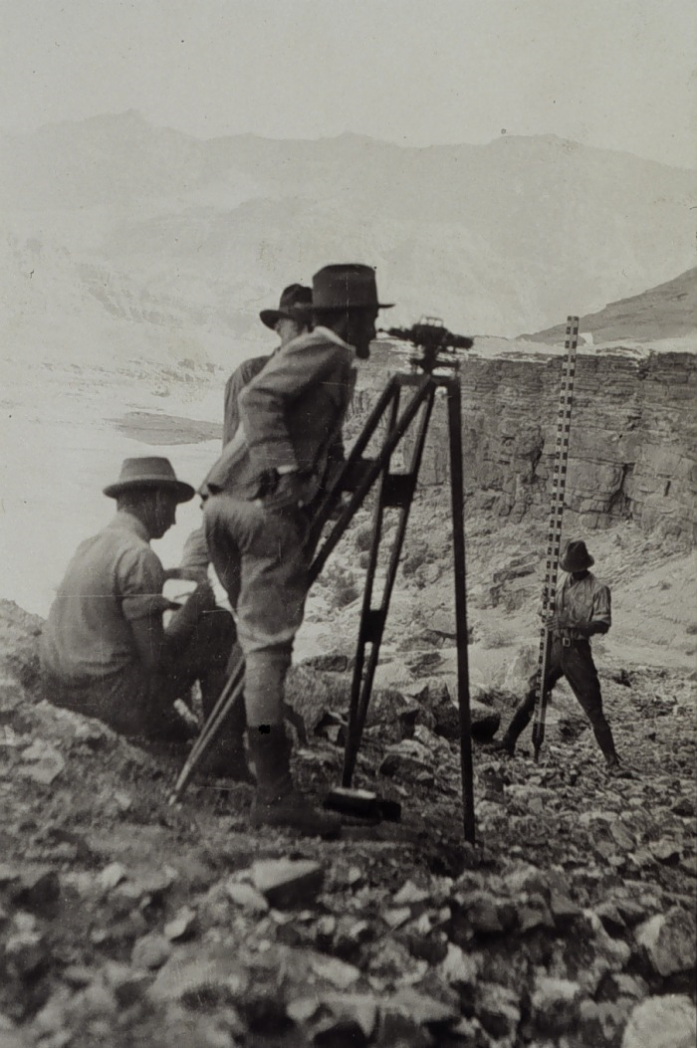

Art Corner

8

1

History Edition

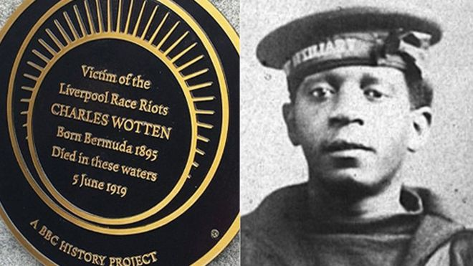

1. As recently dramatized in a critically acclaimed miniseries, what year did the Chernobyl disaster occur?

2. Who was Lord Mayor of London four times between 1397 and 1419, and the inspiration for a classic English folk tale?

3. Who was the second President of the United States?

4. Who was the only one of Henry VIII’s wives to receive a Queen’s funeral?

5.Which British archaeologist discovered Tutankhamun’s tomb?

6. Who was the leader of Britain’s ill-fated Antarctic expedition which was one of the first to reach the South Pole in 1912?

7. In which European country was there a civil war between 1946 and 1949?

8. Which 13th Century Scottish knight did Mel Gibson portray in Braveheart?

9. Which war was fought in South Africa between 1899 and 1902?

10. In which country did the Second World War Battles of El Alamein take place?

11. Who discovered the wreckage of the Titanic?

12. What year did the Challenger Space Shuttle disaster take place?

13. What year was the Magna Carta signed?

14. Which British King suffered from a stammer, as portrayed by Colin Firth in The King’s Speech?

15. What was the name of the ship that brought news of the Battle of Trafalgar to Britain?

16. Which pilot famously fought in the Battle of Britain with two artificial legs?

17. When did the Korean War end?

18. Which real-life American frontiersman did Leonardo DiCaprio portray in The Revenant?

19. Which ship is notorious for experiencing the bloodiest mutiny in British naval history? (Hint – it’s also the name of a Harry Potter character)

20.Who discovered penicillin?

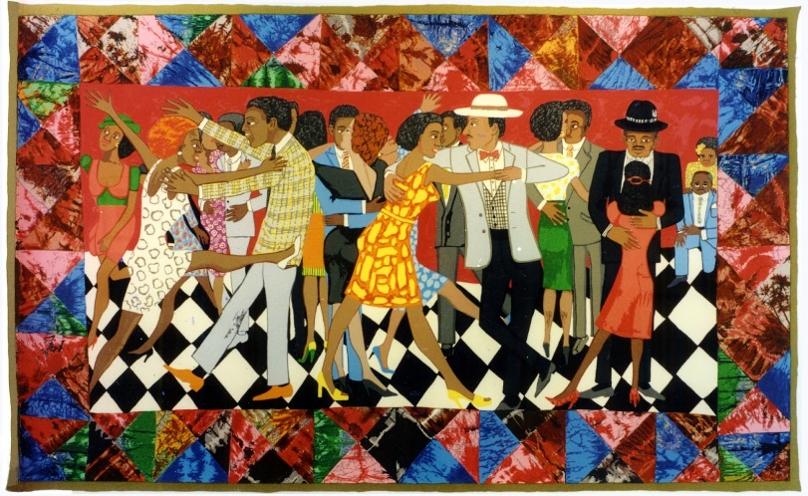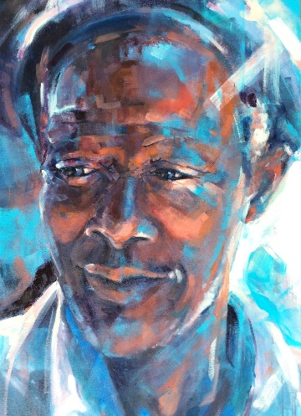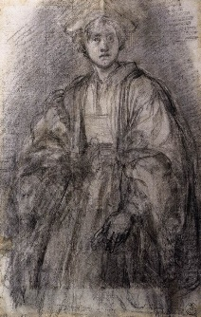

1. A tower  
2. Sloth  
3. Bullfrog  
4. 440  
5. 70 km/h  
6. Dingo  
7. 17th

8. The Emperor Penguin  
9. Australia  
10. Three  
11. Pig  
12. Electric Eel  
13. The bowhead whale, which lives on average for 200 years.  
14. A rabbit  
15. The hippopotamus

5

Ideas for art corner >

2

SOME PEOPLE SAY

LIFE'S A MYSTERY

I WONDER WHY?

Steve, 2020, Haiku Poem

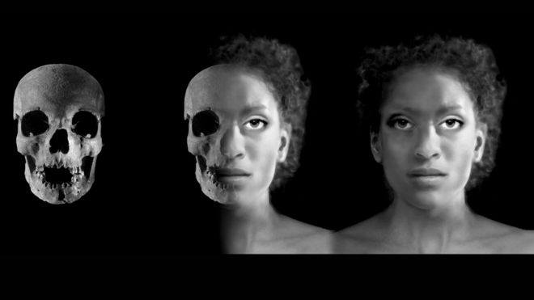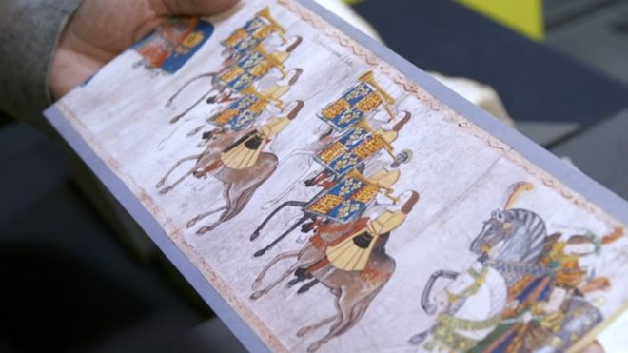

5

4

1. The Ivory Bangle Lady

Some might think the first black people in Britain arrived from Britain's colonies - the countries in Africa, the Caribbean and Asia that Britain ruled over, in some cases for centuries - after World War 2. But that's not true, the Ivory Bangle Lady is the name given to remains discovered in York in 1901 which are now on display in the York Museum. Archaeological analysis reveals that although she was born in Roman Britain, she's likely to be of North African descent. The remains have been dated to the second half of the 4th Century. She was found with jet and elephant ivory bracelets, earrings, pendants, beads, a blue glass jug and a glass mirror. In other words, she wasn't poor. "It puts into question assumptions that black people have never been aspirationally wealthy or had any kind of wealth," Lavinya says.

2. Henry VIII's black trumpeter

During the Tudor period there were hundreds of black migrants living in England. For those of us a bit rusty on our Tudor dates, we're talking about the 1500s. John Blanke, an African trumpeter, was one of them. His face can be seen inscribed into a 60ft long roll depicting the prestigious Westminster Tournament of 1511 - an elaborate party which Henry VIII put on to celebrate the birth of a son. There's even a letter from John Blanke to Henry VIII asking for a pay rise. "He petitioned for 8p a day. I don't know what the conversion is today, but that showed he knew his worth," Lavinya says

3. Britain's first black Queen?

She was a princess from Germany who became a British Queen after marrying King George III - and many historians believe Queen Charlotte had African ancestry. They married in 1761 and Charlotte was the mother of two British monarchs - George IV and William IV. It's been argued that despite coming from Germany, Queen Charlotte was descended from a black branch of the Portuguese royal family. King Afonso III of Portugal conquered the city of Faro from the Moors - Muslims from North Africa who lived in modern-day Spain and Portugal during the Middle Ages - in the 13th Century. Afonso was thought to have had three children with the city governor's daughter. One of their sons, Martim Afonso Chichorro, is also said to have married into a family with black ethnicity. He and his wife, Ines Lourenco de Sousa de Valadares, founded the Portuguese house of Sousa-Chichorro, which had many descendants, including Queen Charlotte. Queen Charlotte's great granddaughter? Queen Victoria.

5 Facts about Black History that you may not Know About…

*"We have existed in Britain and been pioneers, inventors, icons. And then colonialism happened, and that has shaped the experiences of black people - but that is not all we are."*

These are the words of Lavinya Stennett, founder of The Black Curriculum, an organisation which teaches black British history in schools - and is campaigning for Education Secretary Gavin Williamson to make it compulsory.

The death of George Floyd in America has inspired thousands of people in Britain to demand justice, marching through the streets of our biggest cities.

Black Lives Matter protesters here insist that the UK "is not innocent". But some commentators have questioned whether racism exists in Britain, and to what extent. George The Poet, who was questioned about this on Newsnight, believes a lack of education about black British history - and the British Empire - plays a part in racism in the UK and our discussions about it. The transatlantic slave trade and the US civil rights movement are largely the only black history taught in UK schools, normally in October when we celebrate Black History Month."lf you're omitting different histories and narratives, you're saying that these people aren't part of this country, this nation, this heritage - or they're not important enough to be taught as common knowledge," says Melody Triumph, policy specialist at The Black Curriculum.

These are just a few parts of black British history we were not taught in school.

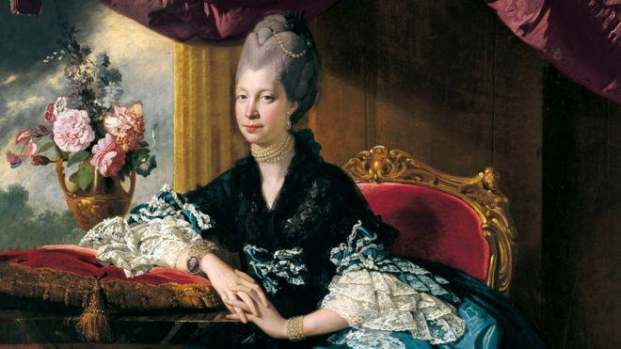

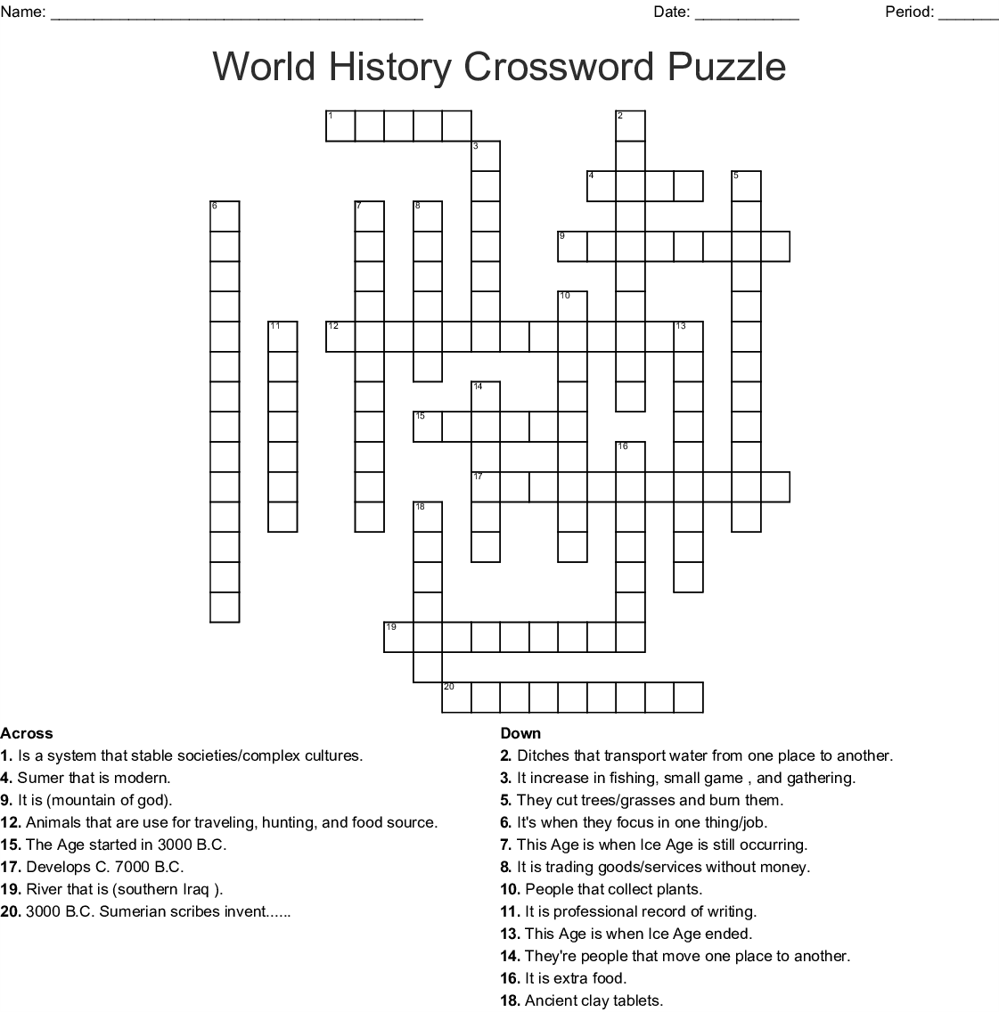

5. WW1 and the race riots that followed

When we talk about Caribbean migration into England we often think about the Windrush generation, who arrived in Britain between 1948 and 1971. "But black people were actually brought over from Jamaica to fight in World War One," says Lavinya. Her great-uncle came to England at the age of 17 to help the war effort, settling in London afterwards. But she says her uncle was "one of the lucky ones"- because he wasn't sent back after the war. When soldiers returned to the UK after WW1 there was a jobs shortage and a lack of opportunities. "White people made the link that they were not getting jobs because of the black people" - and violence towards black communities followed. They're known as the 1919 race riots in Glasgow, Liverpool, Cardiff and other seaports across Britain, during which three people were killed and hundreds injured. But there were economic consequences too. Many black serviceman and workers found themselves without jobs after a "colour bar" was introduced in many industries, with white workers, often backed by unions, refusing to work alongside black people. Lots of black men were sent back to the countries they had lived in before the war. Poverty and a lack of jobs were a big factor in the riots, but according to researcher Jamie Baker, there was also a fear that black men and white women were starting families. "It fits into the hyper-sexualisation of black men. White men felt threatened because they felt that black men were taking their women," Lavinya says.

*See the next page for the image of Charles Wotten, a black serviceman, was killed in the race riots*

4. 'Hidden in plain sight'

Queen Charlotte, whether she had African ancestry or not, joined the Royal Family in the century when Britain started slave-trading - which made it vastly wealthy. "A lot of the time, we start with black history in London - it's London-centric. But a lot of Glasgow's wealth actually comes from the tobacco, the sugar, the cotton that was created and sustained by enslaved people in Jamaica, Trinidad and Barbados," Lavinya says. Many of Glasgow's prominent city centre streets are named after 18th Century slave owners who made fortunes from plantations. "You're told that black people were slaves, but you're not told the fruits of their labour are actually the streets we walk on."

Lavinya says teaching slavery is important but you need to "contextualise it". "Talk about who gained from it, the people not only in the colonies but also here in the UK." That also means teaching about the "black people in Scotland who were part of the abolition of the slave trade".

"All you hear about is William Wilberforce" - a British politician who campaigned to abolish slavery - Lavinya says.

For Videos on this go to <https://www.bbc.co.uk/news/newsbeat-52939694>

World History Crossword

3

6